**CISCO Web**

A website designed for a smooth streaming video call and conferencing. Managed by CISCO, the unique video conferencing website is designed to facilitate companies to manage their discussions online and track progress from home.

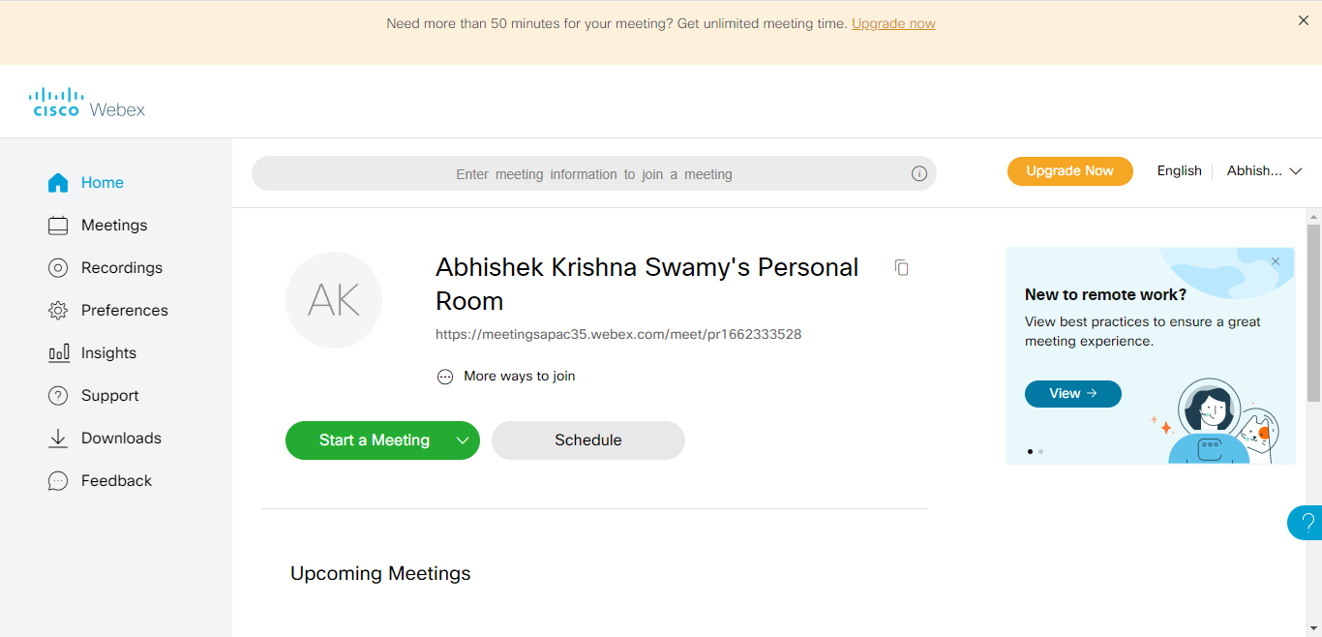

Using a personal id, we can create a workspace and web zone for scheduling and creating meetings. At appropriate date and time, the meetings can be created for a free time of 50 minutes, after which an upgrade can be made for a longer duration.

Features:

* The Meetings toggle button can be used to set a meeting for a certain date and time, which can be recorded.
* The recorded meeting can be played in the Recordings button.

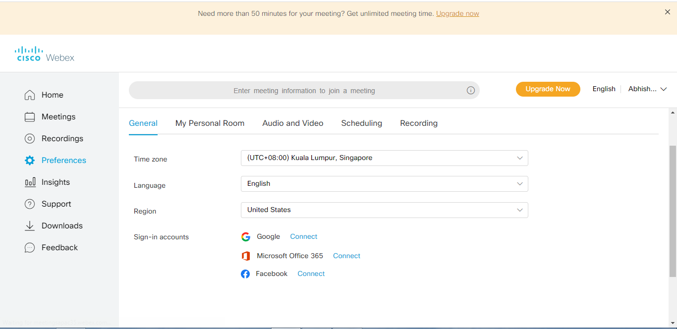

* Using the preferences option, we can set our own outlook on how the meeting is supposed to go.
* Insight give you a detailed report on how many viewers have attended the meetings and gives a detailed statistics with respect to your meetings.
* The Download option allows us to download the required software to allow a smooth meeting. These ca be different versions of Office required to streamline the integration process smooth.
* The support and feedback mechanism designed for user comfort allow technical support at times of need.